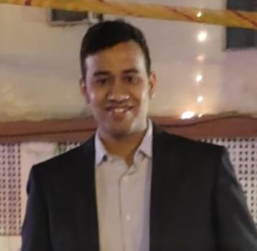

Bhupender Mann

Address: Parivahan Nagar, Jaipur, Rajasthan, 302012.



E-mail: [anujmann19@gamil.com](mailto:anujmann19@gamil.com)

Phone: +91 8905119015

**PROFESSIONAL SUMMARY**

I am a Student of MBA Marketing & Finance. I am looking for a challenging job with a rapidly growing organization that can provide me with a range of goals and job objectives within a contemporary and economical business setting.

**KEY COMPETENCIES**

# |Digital Marketing|MS Office| Social media marketing|MS Excel|

|SPSS |

**INTERPERSONAL SKILLS**

# Team Leadership **|** Decision Maker |

|Task Management |Keen learner| Persistent Problem Solver|

**INTERESTS & HOBBIES**

# Reading Books **|** Travelling**|**Golf|

# Badminton |

**LANGUAGES KNOWN**

# English **|** Hindi | Punjabi|

**PERSONAL DETAILS**

# Mother’s Name: Bimala Mann

Father’ Name: Suraj Mal Mann

D.O.B: 30 March,2000

**EDUCATION**

Masters in Business Administration | Chandigarh University, Gharuan ( Pursuing-2nd semester)

*S*ession: 2022-2023 |

Bachelor in Commerce |University of Rajasthan,Session: 2018-2021 | Percentage: 51%

Intermediate (CBSE) |K.V No.3 Nal, Bikaner, Session: 2017-2018| Percentage: 50%

Matriculation (CBSE) | K.V No.3 Session: 2015-2016| Percentage: 60%

**TRAINING & PROJECTS**

**Asian Paints | Customer Care Associate|May- July 2022**

* Handling conflicts and problems related to customer.
* Consulted with outside parties to resolve discrepancies and create effective solution.
* Documented customer interaction when necessary compiling documents and forwarding information to interested parties.

**CERTIFICATIONS**

* + Personal Development Certification.
  + Financial Markets through Coursera
  + Enterpreneurship Essentials course through Swayam
  + Excel Skills for Coursera.

**EXTRA CURRICULAR & CO-CURRICULAR ACHIEVEMENTS**

* Organization in college function
* 2nd prize in Badminton Competition
* Qualified semifinal in National Badminton Tournament